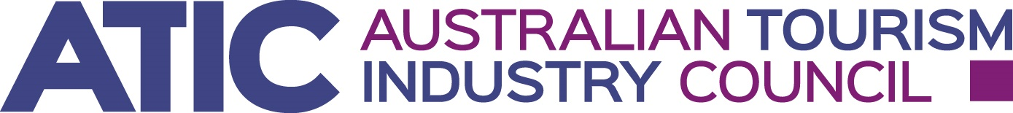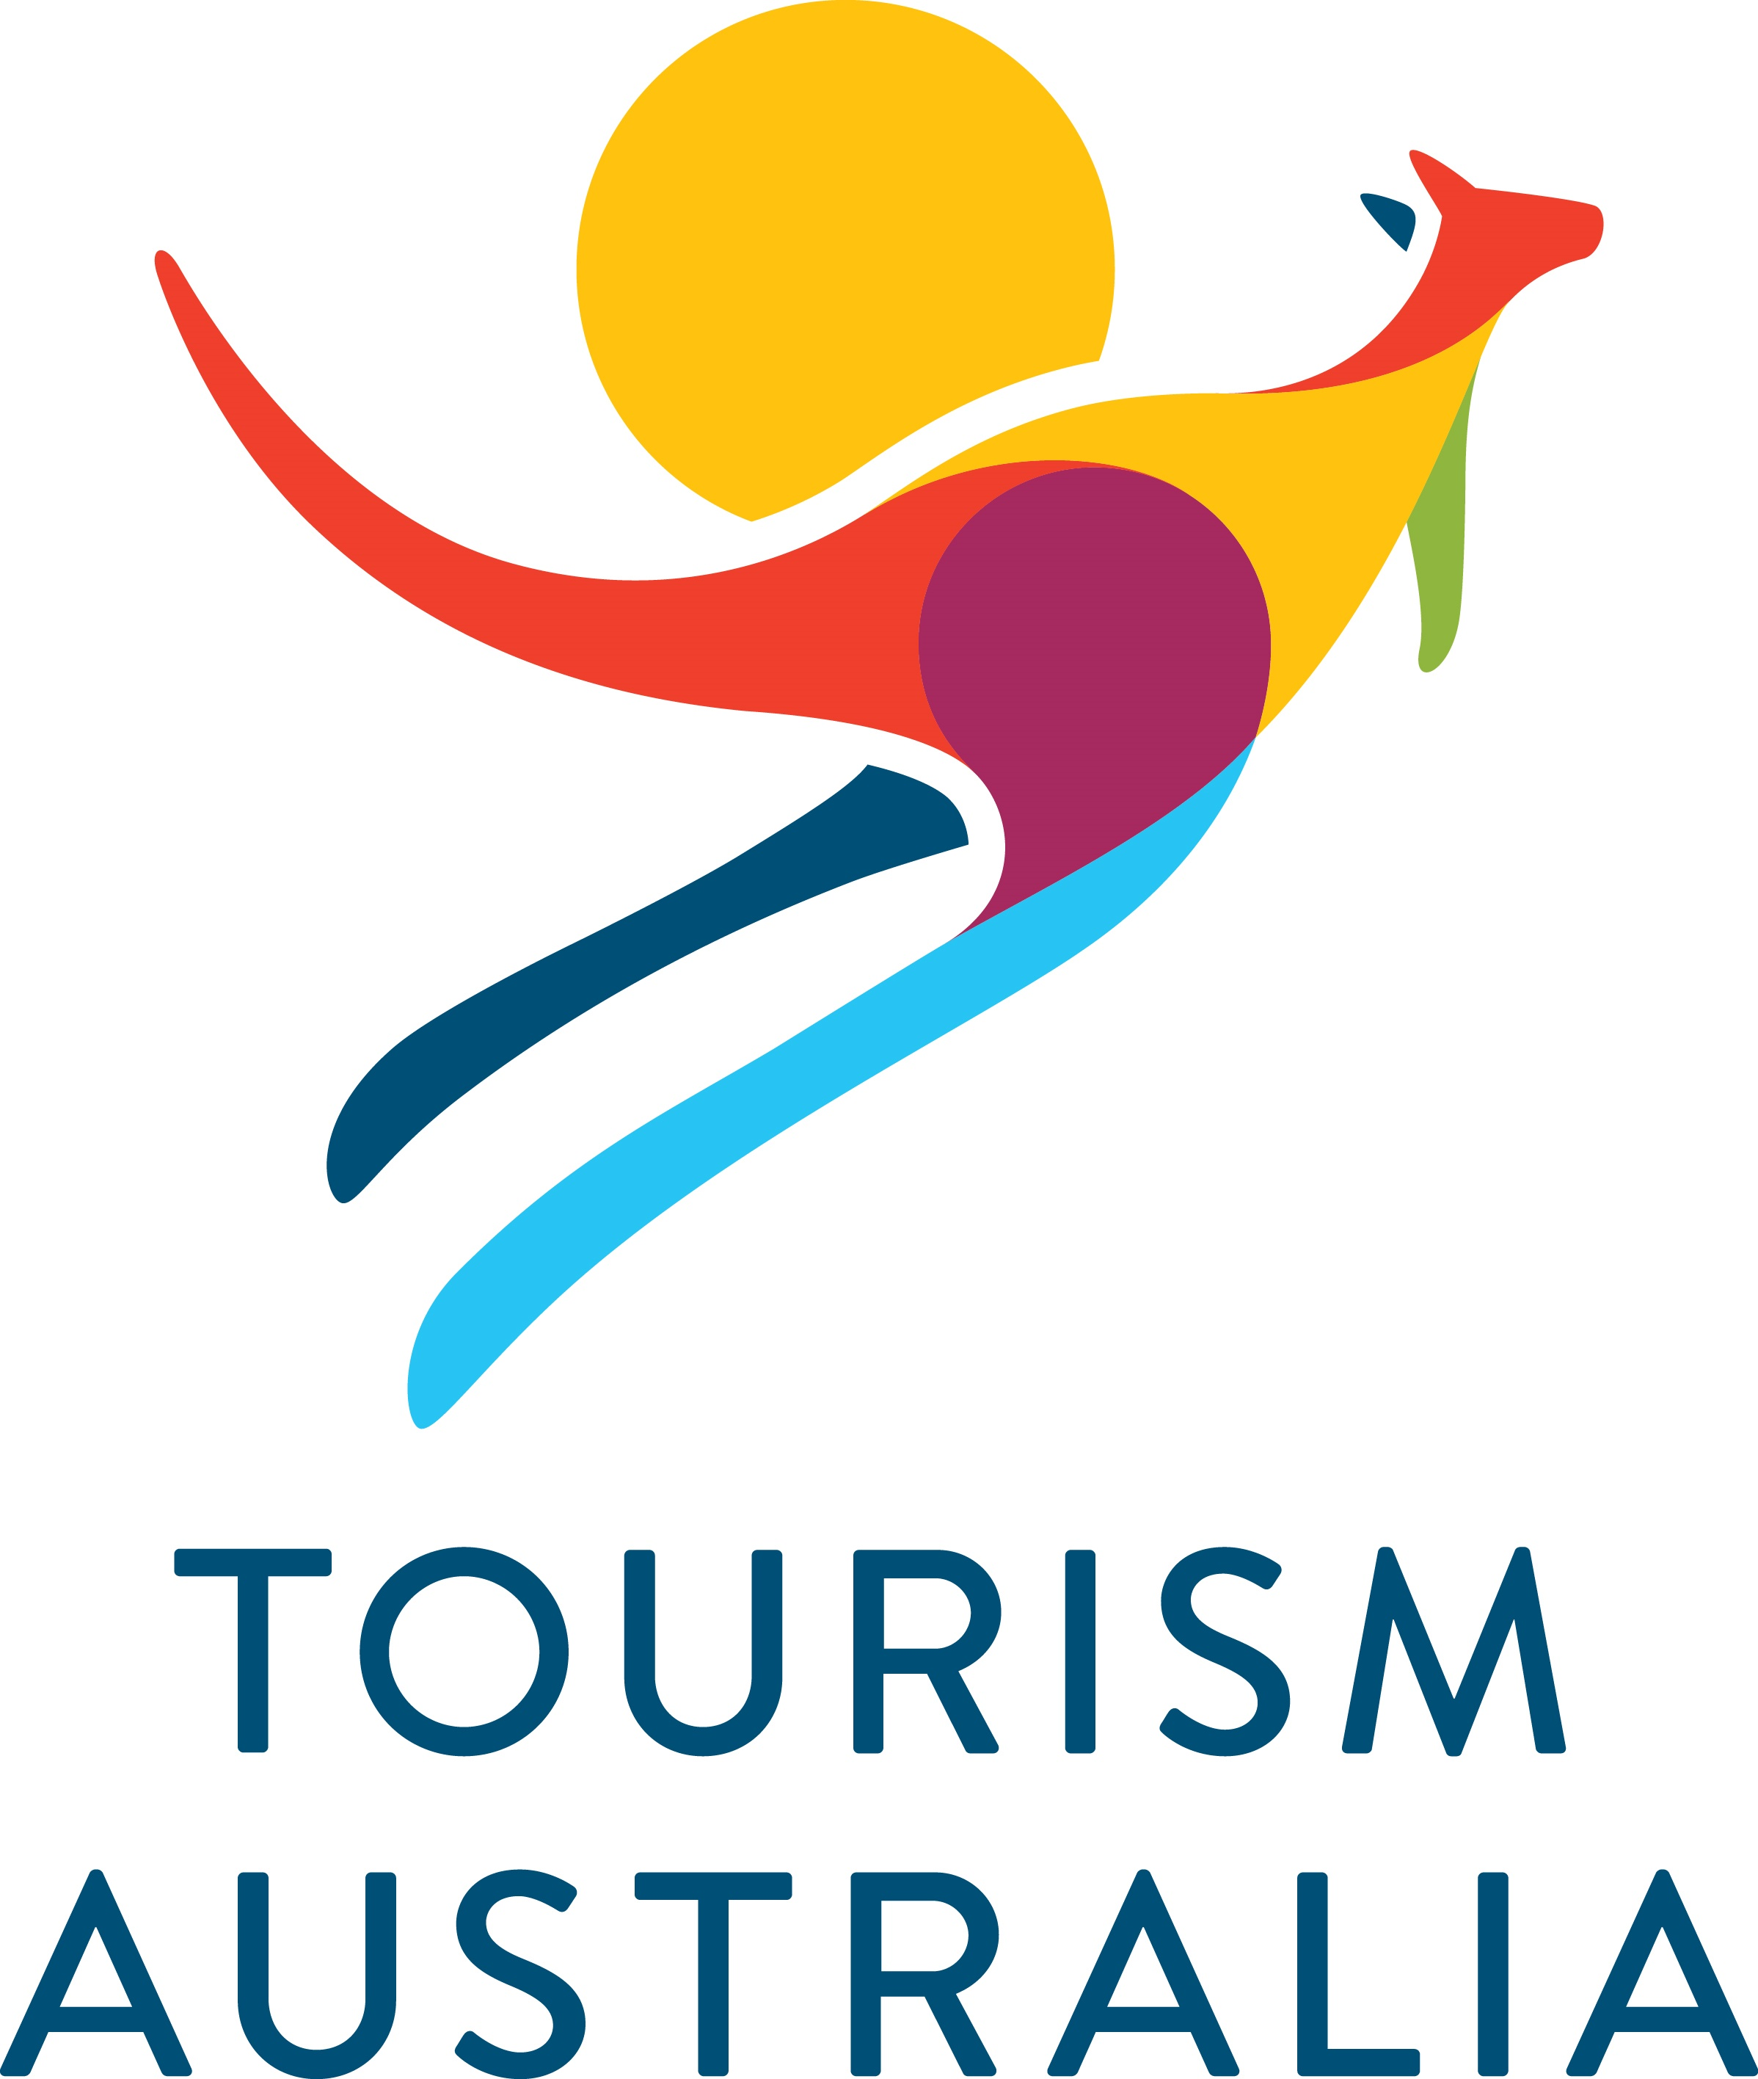

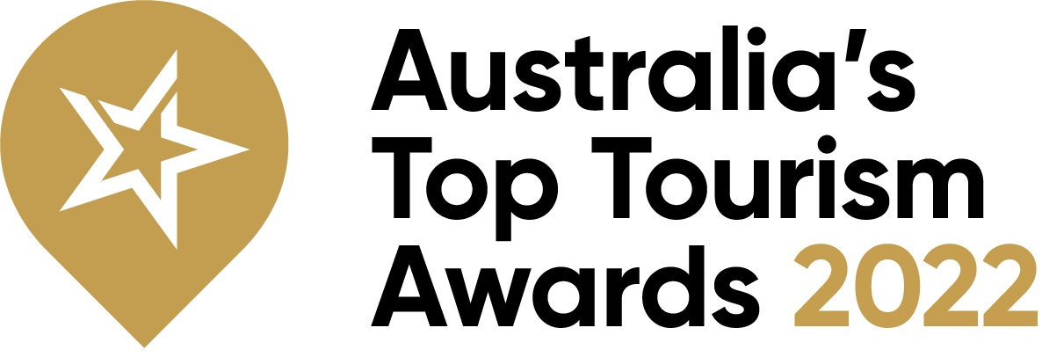

MEDIA RELEASE Tuesday 13th September 2022

Mudgee NSW wins national Top Tourism Town for second year in a row at Parliament House today
The town of Mudgee in NSW has won the major national award of Top Tourism Town for the second year in a row at Australia’s Top Tourism Awards 2022, with the ceremony held today at Parliament House in Canberra.
The awards are presented by the Australian Tourism Industry Council (ATIC) , the national representative body for tourism which provides leadership and representation through a national voice for tourism, and sponsored by Tourism Australia. Winners are determined by a state and national level voting process combining people’s choice votes and an industry judging panel.
“Mudgee has done it again, and we congratulate the town on winning Gold as Top Tourism Town in Australia for 2022,” said ATIC Chair, Evan Hall.
“Mudgee, in the Central West of NSW, is renowned for its strong food and wine scene, and continues to lead regional tourism recovery across Australia. With passionate local operators who connect with visitors at a local, national and international level, Mudgee offers places of historic cultural significance, and an authentic country town experience,” Mr Hall continued.
“Exmouth, on the North West Cape of Western Australia, won Gold in the Small Tourism Town category. Known as the gateway to the nearby Ningaloo Marine Park, Exmouth is popular for diving and snorkelling. And the town really comes together to promote its natural beauty on land and water as one of world’s top destination for marine and wildlife.
“In the Tiny Tourism Town category, Strahan in Tasmania is our Gold winner. Strahan is a remote town at the gateway to World Heritage listed wilderness on Tasmania’s west coast. Pristine waterway and cool-temperate rainforest flank this pristine former port,” Mr Hall continued.
“These awards, part of the Australian Tourism Awards series, showcase the value of tourism to the towns and communities across Australia and celebrate the diversity and outstanding regional destinations from all over the country.
“The awards form part of the new Quality Tourism Framework which combines multiple tourism accreditation, business development and awards programs into a single, user-friendly online tool to develop tourism businesses of all sizes all over Australia to grow their market,” Mr Hall continued.
Today’s award ceremony also revealed Australia’s Top Tour Guide, this year awarded to Jamie Van Jones from Salt and Bush Eco Tours in Western Australia. As part of the formalities, finalists and their guests were addressed by Evan Hall together with Managing Director of Tourism Australia, Phillipa Harrison, who said the Top Tourism Awards recognise the hard work and commitment of tourism communities across the county.
“Our tourism towns are the front line in delivering the high-quality visitor experiences that help to make Australia one of the most desirable destinations in the world,” Ms Harrison said.
“The awards are an important acknowledgement of the incredible efforts of tourism towns, which we know have been through a particularly tough time over the past two years.
“Collaboration within, and across, these towns and communities is key to increasing visitation, dispersal and therefore recovery,” Ms Harrison continued.
See full list of category finalists and winners below. For more information on the Top Tourism Awards by ATIC visit www.toptourismtowns.com.au

MEDIA BACKGROUNDER
Australia’s Top Tourism Awards 2022 – FINALISTS and WINNERS
Category – Top Tourism Town
STATE | TOWN | AWARD
NSW | Mudgee | Gold
VIC | Bendigo | Silver
WA | Mandurah | Bronze
TAS | Launceston
SA | Renmark
QLD | Tamborine Mountain

Category – Small Tourism Town
STATE | TOWN | AWARD
WA | Exmouth | Gold
TAS | Sheffield | Silver
VIC | Port Fairy | Bronze
QLD | Airlie Beach
NSW | Berry
SA | Wallaroo

Category – Tiny Tourism Town
STATE | TOWN | AWARD
TAS | Strahan | Gold
QLD | Winton | Silver
VIC | Mount Macedon | Bronze
WA | Denham
SA | Quorn
NSW | Carcoar

Category – Top Tour Guide
STATE | GUIDE | AWARD
WA | Jamie Van Jones – Salt and Bush Eco Tours, WA. | Gold

For more information on the Top Tourism Awards by ATIC visit www.toptourismtowns.com.au

MEDIA CONTACT: For more information, images or interviews contact Lauren Griffiths, Threesides, on 0417 409 264 or lauren.griffiths@threesides.com.au

